**Booked Counseling** [**https://citria.org/admin/book-counselling**](https://citria.org/admin/book-counselling)

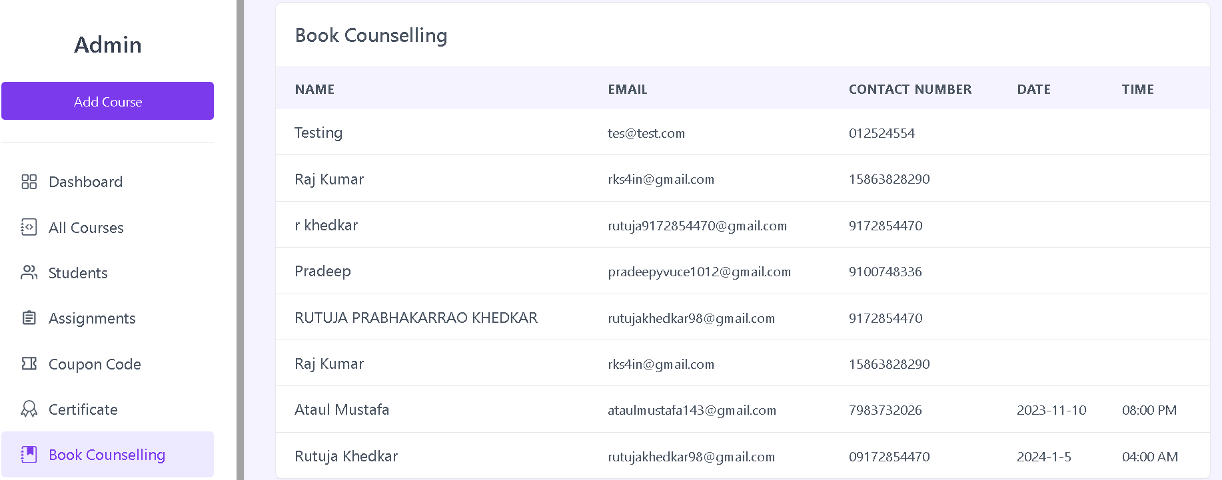

This is a React component to display a list of book counselling requests. Here is what it does:

1. Uses the useGetAllBookCounselling custom hook to fetch the book counselling data and loading state.
2. Renders a table with columns for:
   * Name
   * Email
   * Contact Number
   * Date
   * Time
3. Shows a loading skeleton if data is still loading.
4. Maps through the counseling requests and displays each one in a table row.
5. Displays the date and time slots in an unordered list if there are multiple.
6. Conditionally shows a no requests message if the list is empty.
7. Has commented out code to open a modal to view resumes when clicking the "View" button.

So in summary, it is reusing the data fetching logic and providing a clean table layout to display the counselling requests. Helps keep the display reusable across the application.